The Diocese of Wangaratta
The Anglican Parish of Kilmore
with Broadford, Pyalong & Tallarook
13th April 2014
Palm Sunday

Hymns: 333, 348, 279, 357

The Palm Sunday Liturgy
The community gathers with the children, animals and palms outside in the gardens. Passports are checked for entry into the city.

Grace and peace to you from God.
God fill you with truth and joy.

Dear friends in Christ, during Lent we have been preparing for the celebration of Christ's death and resurrection. Today we come together to begin this solemn celebration in union with the church throughout the world. Christ entered Jerusalem this day in triumph, a triumph that led through suffering and death to resurrection and new life. In faith and love may we follow this messiah, the humble ruler, who comes riding on a donkey.

Let us pray.
Silence
God of our salvation, help us to enter with joy into the celebration of those mighty acts by which you have given us fullness of life; through Jesus Christ our Redeemer. Amen.

The Lord is here.
God's Spirit is with us.

Let us give thanks to God.
It is right to offer thanks and praise.

It is right to praise you, Sovereign God, for the acts of love by which you have set us free. On this day Jesus entered Jerusalem triumphantly to suffer and to die and was greeted with branches of palm. Let these branches be for us symbols of martyrdom and majesty. May we who carry them follow Christ in the way of the cross which leads to life; through Christ who lives and reigns in glory with you and the Holy Spirit, now and for ever. Amen.

Palms are distributed if not already.

Let us go in peace.
Amen. We go in the name of Christ.

Introit Hymn 333 as we enter the church with the palms

The Lord be with you:
And also with you.
Bless the Lord who forgives all our sins,
Whose mercy endures for ever.

Christ has reconciled us to God in one body by the cross.
We meet in his name and share his peace.
The peace of the Lord be always with you.
And also with you.
All may exchange a sign of peace

The Liturgy continues on page 119 Green Prayer Book

SENTENCE
At the name of Jesus, every knee shall bend, in heaven and on earth and under the earth, and every tongue confess that Jesus Christ is Lord, to the glory of God the Father. Philippians 2.10-11

THE COLLECT
Sovereign God, you have established your rule in the human heart through the servanthood of Jesus Christ. By your Spirit, keep us in the joyful procession of those who with their tongues confess Jesus as Lord and with their lives praise him as Saviour, who lives and reigns with you and the Holy Spirit, one God, now and forever. Amen.

FIRST READING Isaiah 50.4-9a

A reading from the book of the prophet Isaiah
The Sovereign Lord has given me a well-instructed tongue, to know the word that sustains the weary. He wakens me morning by morning, wakens my ear to listen like one being instructed. The Sovereign Lord has opened my ears; I have not been rebellious, I have not turned away. I offered my back to those who beat me, my cheeks to those who pulled out my beard; I did not hide my face from mocking and spitting. Because the Sovereign Lord helps me, I will not be disgraced. Therefore have I set my face like flint, and I know I will not be put to shame. He who vindicates me is near. Who then will bring charges against me? Let us face each other! Who is my accuser? Let him confront me! It is the Sovereign Lord who helps me. Who will condemn me? They will all wear out like a garment; the moths will eat them up.

Hear what the Spirit is saying to the Church. Thanks be to God.

RESPONSORIAL PSALM Psalm 118,1-2,19-29

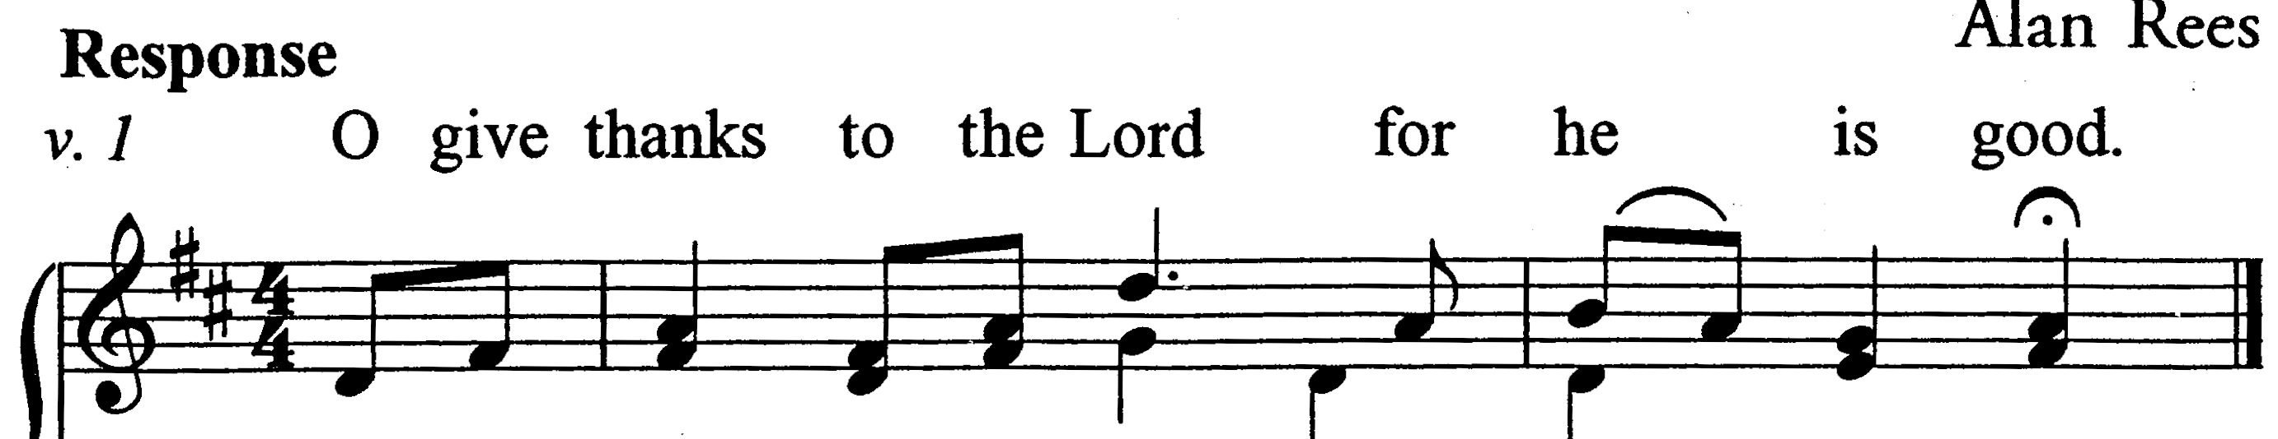
Response: O give thanks to the Lord for our God is good.
O give thanks to the Lord, for he is good;
his mercy endures for ever.
Let Israel now proclaim,
'His mercy endures for ever.'
Open to me the gates of righteousness,
that I may enter and give thanks to the Lord.
This is the gate of the Lord;
the righteous shall enter through it./R

I will give thanks to you, for you have answered me
and have become my salvation.
The stone which the builders rejected
has become the chief cornerstone.
This is the Lord's doing,
and it is marvellous in our eyes./R

This is the day that the Lord has made;
we will rejoice and be glad in it.
Come, O Lord, and save us we pray.
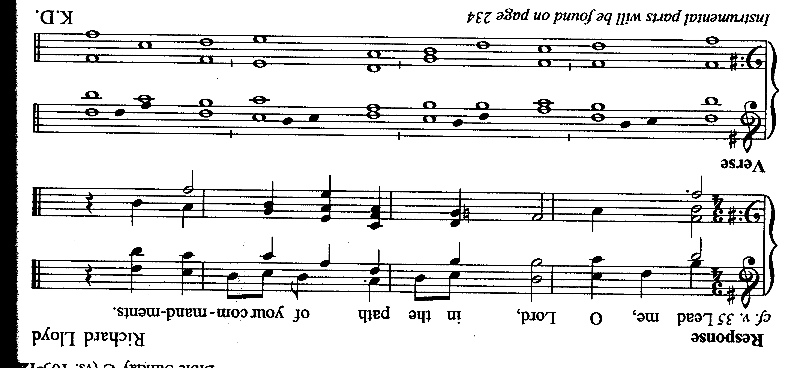
Come, Lord, send us now prosperity.
Blessed is he who comes in the name of the Lord;
we bless you from the house of the Lord./R

The Lord is God; he has given us light;
link the pilgrims with cords
right to the horns of the altar.
You are my God and I will thank you;
you are my God and I will exalt you.
O give thanks to the Lord, for he is good;
his mercy endures for ever./R

SECOND READING Philippians 2.5-11

A reading from the letter to the Philippians

In your relationships with one another, have the same mindset as Christ Jesus: who, being in very nature God, did not consider equality with God something to be used to his own advantage; rather, he made himself nothing by taking the very nature of a servant, being made in human likeness. And being found in appearance as a man, he humbled himself by becoming obedient to death – even death on a cross! Therefore God exalted him to the highest place and gave him the name that is above every name, that at the name of Jesus every knee should bow, in heaven and on earth and under the earth, and every tongue acknowledge that Jesus Christ is Lord, to the glory of God the Father.

Gradual Hymn

GOSPEL ACCLAMATION
Praise to you O Christ, King of eternal glory.
Praise to you O Christ, King of eternal glory.
Christ humbled himself and became obedient to the point of death
even death | on a cross.
Therefore God also highly exalted him
and gave him the name that is above | every name.
Praise to you O Christ, King of eternal glory.

GOSPEL Matthew 21. 1-11
A reading from the holy gospel according to Matthew
Jesus went on ahead, going up to Jerusalem. When he had come near Bethphage and Bethany, at the place called the Mount of Olives, he sent two of the disciples, saying, “Go into the village ahead of you, and as you enter it you will find tied there a colt that has never been ridden. Untie it and bring it here. If anyone asks you, ‘Why are you untying it?’ just say this, ‘The Lord needs it.’” So those who were sent departed and found it as he had told them. As they were untying the colt, its owners asked them, “Why are you untying the colt?” They said, “The Lord needs it.” Then they brought it to Jesus; and after throwing their cloaks on the colt, they set Jesus on it. As he rode along, people kept spreading their cloaks on the road. As he was now approaching the path down from the Mount of Olives, the whole multitude of the disciples began to praise God joyfully with a loud voice for all the deeds of power that they had seen, saying, “Blessed is the king who comes in the name of the Lord! Peace in heaven, and glory in the highest heaven!” Some of the Pharisees in the crowd said to him, “Teacher, order your disciples to stop.” He answered, “I tell you, if these were silent, the stones would shout out.”

For the Gospel of the Lord. Praise to you, Lord Jesus Christ.
THE PRAYERS OF THE FAITHFUL
Lord Jesus you who disturbs the complacent and the righteous, you come riding on a donkey to usher in God’s new kingdom; people like us raise their branches and voices in celebration of the hope of new life singing, “Hosanna to the Son of David! Blessed is the one who comes in the name of the Lord”; grant us the grace, to sing and pray with our hearts as well as our lips, and to serve you with our deeds as well as our prayers. Lord hear us.

In places where the church celebrates with joy today, where it laughs with little children and praises with elderly saints, where clergy call for hosannas that overflow from every loving heart; May your kingdom come: Your will be done, on earth as it is in heaven.

In places where the church gathers in sorrow or fear today, weeping with Christ Jesus for the cross that must be carried in the face of misunderstanding and abuse; May your kingdom come: Your will be done on earth as it is in heaven.

In places where there are small hopes begging to be kept alive, programmes of compassion needing to be supported, and the beginnings of faith requiring recognition and encouragement; May your kingdom come: Your will be done on earth as it is in heaven.

In places where ordinary people are disillusioned when greed and injustice wants the poor and the weak blamed for the deprivations that afflict them; May your kingdom come: Your will be done on earth as it is in heaven.

In places where people are at their wits end, angry or frightened, ready to hit out violently at those around them, or falling into despair and planning to take their own lives; May your kingdom come: Your will be done on earth, as it is in heaven.

In places where people suffer with sickness, pain, grief or loneliness; May your kingdom come: Your will be done on earth, as it is in heaven.

In places where people cry out in need for prayer especially those known to us and those who have requested prayer ….
Request for prayer from: Chris Schafer, Glen Turnbull, Karen Goodger, Lyn Ryan, Alex Impols, May McCormack, Dawn McCormack, Carol Boase, Cathy Moseley, Fr Michael Nelson, Seth Gunter, David Parsons, Cliff & Gwen Stomann, Tom & Sandra Davidson & Bianca Davidson, Adrian Walsh, Dianne Mitsakis, Bruce Mitchell, Mark Bennetts, Suresh Jain, Barry Watts…..
May your kingdom come: Your will be done on earth, as it is in heaven.

In places where the dying and those who wait with them surrender themselves to your love; May your kingdom come: Your will be done on earth, as it is in heaven.

For those who have departed this life to enter your nearer presence and those who years mind occurs at this time;
Rest eternal grant to them O Lord: And let light perpetual shine upon them.

Life-giver, Pain-bearer, Love-maker, day by day the weary are sustained with your word and we are gently encouraged us to place our trust in you; accept our prayers through him who turns our sorrows into joys and shows us the way of righteousness and peace, and taught us to pray: Our Father ......[pg. 124]

Year’s mind: Today we remember before God those whose anniversary of death occurs this week: 13th John Salmon, Ken Poulter, Kathleen Pelham, John Hedley: 14th Brightie Lang: 15th Eric Williams, James Evans; 16th Walter Rasmussen, Geoffrey Ryan, Alan Wicking; 17th Dorothy Green, Jack Poulter; 18th Serge Akishev.
Reflections on the Readings

Palm Sunday is another one of those moments when it is easy to fall back on the same old ideas and images and yet this celebration is a powerful beginning to a very moving journey through Holy Week. For this day must always be seen in the light of the rest of what is to come this week; this moment of entry into Jerusalem in such a defiant way was a very definite and intentional decision by Jesus to face the suffering which lay ahead. Rather than avoid the confrontation and its consequences, Jesus faces them square on, and refuses to shy away from the suffering, or change his message or methods in order to stay safe. In a world in which pain-avoidance has become almost a religion in itself, this example is deeply challenging – as is the cause of Jesus’ pain: his insistence on living according to God’s alternative way and his refusal to bend to the demands or threats of empire and its systems. And so Holy Week begins! The big challenge of this period in the Church Calendar is that the focus is so very clearly on events that happened to this “someone else” so very long ago. Yet, we are privy to the unique calling and nature of Jesus, and the unique character of these events, hence the pattern of services offered this week in the Parish. There are no prerequisites for participating, other than that of wanting to somehow connect with this profound human story. We start each day Monday - Wednesday with a mass at Christ Church and in the evening The Tenebrae Service of Shadows repeated once in each centre. Tenebrae focuses on Jesus’ journey with readings and music and meditation. Maundy Thursday starts with an early service at Christ Church and in the evening the Liturgy of Footwashing and Celebration of the Last Supper at St Matthew’s only. The Last Supper is when Jesus gathers with his disciples in a room to celebrate the passover and the Institution of the Eucharist is central to the action; but from there the passion of the Christ begins and its torrid journey through betrayal and desertion, arrest and trial and finally to the execution by crucifixion which is the focus of the Good Friday Liturgy. On Good Friday a dramatic reflection on the Passion of our Lord is offered in each centre at usual worship times. The Easter Vigil, the Lighting of the new Fire and the Easter Proclamation that Christ is risen starts at dawn on Easter Day. This is then followed by Parish Breakfast with the First Mass of Easter celebrating the Resurrection of our Lord, at Christ Church and these constitute the great Easter celebration.

Notices

TODAY 12.30p.m. Parish BBQ - Mine host Ian and Lucy Staring - 40 Dockerys Road, Tallarook. Dockerys Road runs of the Hume Highway, travelling north towards Seymour. Turn left at the first road (Dockerys Road) after the weighbridge. It is 3kms before the Tallarook township exit. The house is the first house in Dockerys Road on the right. Its only 150 meters from the Hume Highway. Bring your fishing rods or yabby nets, meat, salad or sweets. There will be ample red wine to indulge in. All welcome to attend.

Service times for Holy Week are below in Parish Life this Week.

Parish Council Meeting has been moved from this coming Wednesday to Wednesday 23rd April at 7.30pm because of Holy Week. The meeting will be at Gavan Hall.

Memorial Service at Caladenia Aged Care to be held on Thursday 24th April at 2.30pm.

Casseroles for the BlazeAid Team
Helen Begley is coordinating cooking of casseroles every second Tuesday for the BlazeAid Team. Meals required at the Wandong Community Centre at 6.00pm. Helen can arrange delivery if required. Ring Helen 5782 1625 if you can help.

Direct Debit Offerings - Parish Account details: CBA Account Name ‘Kilmore Anglican Parish’. BSB 063-698. Account Number 1018 4649.

Parish Diary

1st Wed of the month: Building and Maintenance Committee Meeting 7.30pm (venue TBA)
2nd Sun of the month: Parish BBQ - 12.30pm. See Notices for details

3rd Tues of the month: St Matthew’s Friendship Group. Gavan Hall 1.30pm fellowship & afternoon tea; contact Edie Simpson ph. 5784 1246 for details.
3rd Wed of the month: Parish Council Meeting, 7.30 pm venue TBA

4th Thurs of month: Christ Church Friendship Group 7.30pm contact Beris Hannam ph. 5723 9737 for program details
4th Sunday of month: Church 4 Kids 5-6.30pm @ Christ Church

Parish life this week

Third week of April - Holy Week
Monday 14th 7.30am Eucharist Christ Church
7.30pm Service of Tenebrae St Stephens
Tuesday 15th 7.30am Eucharist Christ Church
1.30pm St Matthew’s Friendship Group - Gavan Hall
7.30pm Service of Tenebrae St Matthews
Wednesday 16th 7.30am Eucharist Christ Church
7.30pm Service of Tenebrae Christ Church
Thursday 17th 7.30am Eucharist Christ Church
10.00am Eucharist St Matthews
10.00am Eucharist Willowmeade
4.00pm Eucharist Dianella
7.30pm Maundy Thursday Liturgy St Matthews
10am - 4pm Op Shop Church House
Friday 18th 9.00am Good Friday Liturgy Christ Church
11.00am Good Friday Liturgy St Matthews
11.00am Good Friday Liturgy St Stephens
4.00pm Good Friday Liturgy Transfiguration
Op Shop Church House CLOSED
Saturday 12th 10.00am - 12.30pm Op Shop Church House

Next Sunday: 20th April 2014 - EASTER DAY
Christ Church | 7am | Easter Vigil, Lighting of the new fire
 | 8am | Parish Breakfast
 | 9am | First Mass of Easter
St Matthews | 11am | Mass of Easter combined with St Stephens
St Stephens | 11am | No service - combined with St Matthews
Transfiguration | 4pm | Mass of Easter

Parish Clergy:
Rector Fr Kim Benton 9 Union Street Kilmore 3764 Ph 5782 1155
m 0407569343; kim@revkim.org

Priest (PTO) Fr John Young 9/40 Powlett St Broadford 3658 Ph 5784 2224

PO Box 289 Kilmore 3764

Like us on

